Consulting Proposal for Verified Knowledge Handover at Spark New Zealand
INFOSYS 704 Assignment 2 Deliverable 1
Prepared for Spark New Zealand Limited
Prepared by Xuan Zeng
Decision requested
Approve a proposed 52-week phased trial of a gated knowledge handover process for knowledge-critical role exits, starting with a four-week validation phase.

Contents
1 Executive Summary
2 Client Context and Problem Statement
3 Objectives and Success Criteria
4 Proposed Approach
5 Proposed Methodology
6 Work Plan and Timeline
7 Team and Capabilities
8 Change Management
9 Risk Management
10 Expected Impact and Value Creation
11 Client Responsibilities and Collaboration Model
12 Commercials
13 Next Steps
14 Learning Journeys
15 References and Academic Integrity
Appendix A Key Assumptions

1 Executive Summary
Spark reported 3,847 full-time equivalent employees at 30 June 2025 after reducing its workforce by about 1,300 full-time employees. This followed a stated plan to remove about NZ$50 million in labour costs. The earlier diagnosis found that Spark's exit process controls payroll, assets and access, but does not require evidence that operational knowledge has reached the team taking over the work. This can lead to rework, slower issue resolution and unplanned contractor use, with the recovery costs spread across operating budgets (Pelletier, 2024; Spark New Zealand, 2025a).
This proposal recommends a gated knowledge handover for knowledge-critical roles. Each exit would have a criticality check, a named receiving owner, a standard handover pack and a competence check based on real tasks. If the receiver cannot complete the check, the case would move to remediation or a named exception. Access revocation would still happen on schedule. Where records are needed after the exit, the receiving owner would receive time-limited, read-only access instead of extending the departing employee's access.
The 52-week plan comes from the 12-month target and roadmap developed in A1-D2. It is a proposal to be tested, not a duration confirmed by Spark. The first four weeks are therefore used to check the data, case volume, system constraints and staff capacity before Spark commits to the later phases. The remaining plan covers configuration, a Connectivity pilot, extension to Digital Services, and a longer period for stabilisation and benefits tracking. This phased approach allows the later rollout to use what is learned in the pilot (INFOSYS 704, 2026).
By week 52, the project aims to reach at least 90% Verified Handover Completion, 100% Criticality Assessment Coverage, a median verification lead time of at least five working days, and an annual recovery of NZ$1.4 million. The proposed fee is NZ$97,350. Using a 50% benefit ramp in year one, the model gives a three-year nominal benefit of NZ$3.5 million against NZ$157,350 of implementation and governance cost. These figures remain working estimates until Phase 0 tests them against Spark's records. Spark is asked to approve the proposed Phase 0 start on 28 September 2026, nominate the sponsor and process owner, and allow controlled access to pseudonymised data.

2 Client Context and Problem Statement

2.1 Client context and urgency
Spark is New Zealand's largest telecommunications company, and its SPK 30 strategy depends on network quality, customer experience and stronger financial performance. The operating environment remains difficult: the Commerce Commission reports continued competition and changing demand, while Consumer NZ's 2025 survey gave Spark mobile a satisfaction score of 63%, placing it near the bottom of the providers shown (Commerce Commission, 2025; Harvey, 2025). Spark has responded with cost reduction and a renewed focus on profit growth. In July 2026, it also separated Connectivity from Digital Services while the future of Digital Services was reviewed (Bennett, 2026; Spark New Zealand, 2025b, 2026).
This timing matters because the affected customer-facing and technical roles depend heavily on experience that may not be written down. If more roles are removed or redesigned before a stronger handover control is in place, teams may have to rebuild that knowledge after the employee has left.

2.2 Problem statement
Problem. Spark's exit process does not reliably transfer the knowledge needed by the team taking over the work. There is no common evidence standard, no required confirmation from the receiving side and no completion measure. The likely result is rework, slower fault resolution and unplanned contractor support, which can reduce the savings expected from the cost programme.
Target. Within 12 months, achieve at least 90% verified handover completion for knowledge-critical exits and establish a supported route to NZ$1.4 million in annual savings from lower rework and unplanned contractor use, measured against a validated FY26 baseline.
Table 1 Current process indicators and pain points
Current indicator | Working baseline | Pain point | Source or validation
Verified handover completion | Below 50% estimated | A filed document may not have been accepted or tested by the receiver | Phase 0 artefact and timestamp review
Criticality assessment coverage | No consistent measure identified | Risk is discovered after the exit | HRIS and entitlement review
Verification lead time | Not measured | Late sign off can become a rubber stamp | New HRIS dates
Annual leakage | NZ$1.1m to NZ$4.0m | Costs are not linked to exits | Finance and ITSM

Figure 1 AS IS employee exit and knowledge handover process
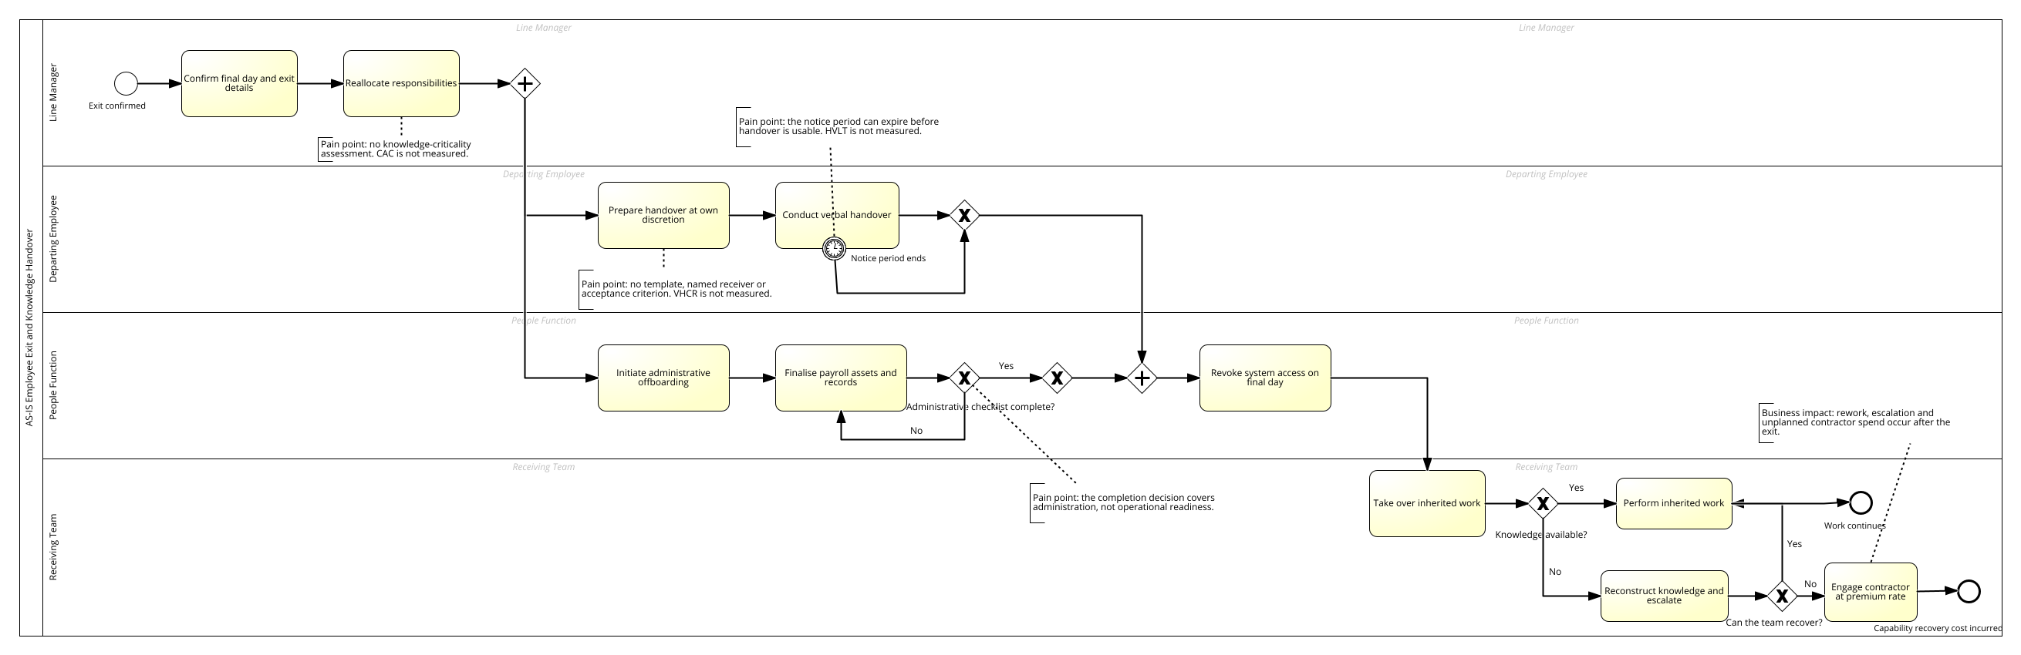
The current administrative process finishes when access is revoked. The receiving team's work to rebuild missing knowledge starts after that point and is not controlled by the exit process. The missing step is a receiving-side check that the work can continue.

3 Objectives and Success Criteria
The proposal has four practical objectives. Together, they are intended to protect operating capability while keeping Spark's cost discipline in place.
- Create a verifiable completion condition for knowledge transfer in every knowledge critical exit.
- Detect knowledge critical roles within five working days of exit confirmation.
- Reduce post exit rework, escalation and unplanned capability recovery cost.
- Create a repeatable control that can later cover internal transfers and role redesigns as well as exits.
Table 2 Objectives and measurable success criteria
Measure | Definition | Target | Frequency and owner
VHCR | Critical exits whose receiving owner passes the competence check before the last working day divided by all critical exits | 60% by week 20, 75% by week 32, 90% by week 52 | Monthly, People process owner
CAC | Confirmed exits receiving a documented criticality assessment within five working days | 80% by week 12 and 100% by week 32 | Monthly, HRIS owner
HVLT | Median working days between verification and last working day | At least 5 days and no more than 10% after the last day | Monthly, process owner
Capability recovery cost | Rework and unplanned contractor cost attributable to a critical exit | NZ$1.4m annual run rate reduction after validation | Quarterly, Finance
90 day reopen rate | Critical exits producing a knowledge related escalation within 90 days | 25% reduction from validated baseline | Quarterly, IT service owner

4 Proposed Approach

4.1 Hypothesis driven strategy
The approach starts with a testable explanation for the problem, then links each failure to a process control and a piece of evidence. This keeps the recommendation connected to the findings from A1-D1 and A1-D2. It also makes the process model easier for business users to question and improve, which addresses Rosemann's (2006) concern that process models lose value when users do not understand or own them.
The main hypothesis is that knowledge is lost because it is treated as an informal outcome inside an otherwise controlled exit process. If Spark makes the receiving owner responsible for confirming completion, handover quality should improve and recovery costs should fall. Phase 0 tests whether the control gap and value case are supported by Spark's data. The pilot then tests whether the proposed control works in day-to-day conditions. Table 3 links the problem, the control and the evidence, while Figure 2 shows where the process changes.
Table 3 Intervention logic
Observed failure | Proposed control | Evidence generated
No criticality test | Rules based triage using role, entitlement, tenure and system ownership data | CAC and classification overrides
No accountable receiver | Named receiving owner assigned when exit is confirmed | Owner assignment and exception log
Unstructured capture | Standard pack driven by the receiver's stated requirements | Complete and comparable artefact
No quality gate | Demonstrated competence on two or three real tasks | VHCR and remediation cycles
Costs remain invisible | Link exit, ITSM and finance records using pseudonymised keys | Benefit tracking and attribution

4.2 TO BE process
The TO-BE process keeps security offboarding separate from knowledge completion. The departing employee's access is still revoked on schedule. If records are needed later, the receiving owner receives controlled read-only access. A failed competence check blocks backfill approval and creates a named exception, but it does not delay access revocation.

Figure 2 TO BE gated knowledge handover process
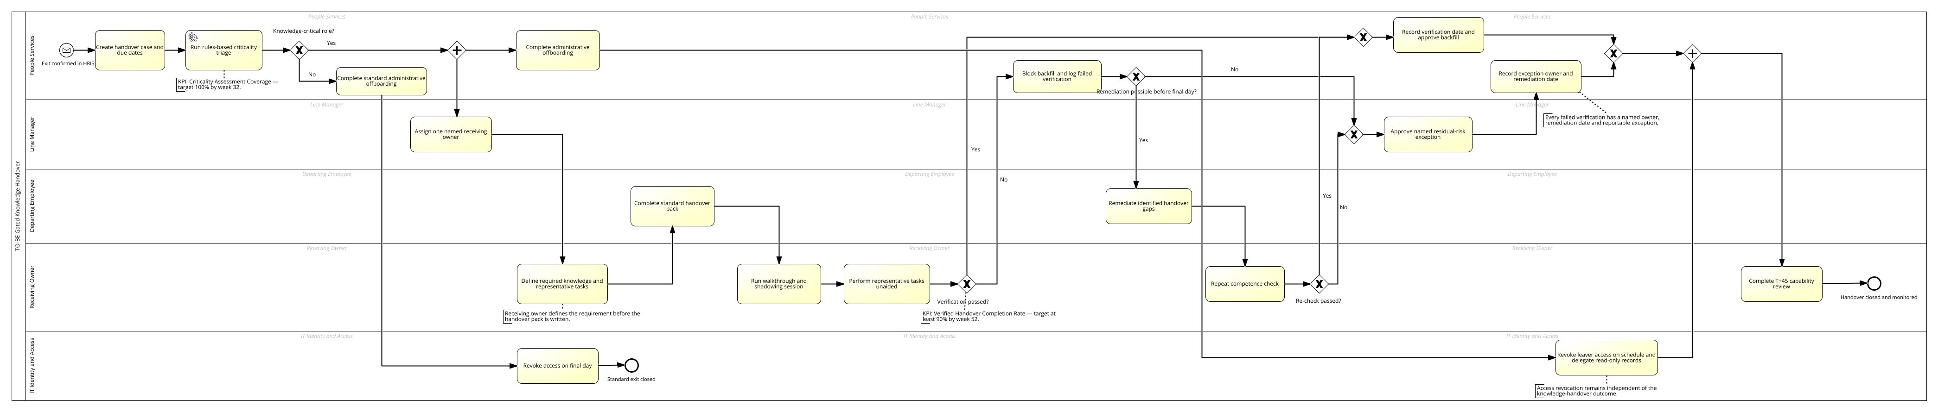
Compared with the current process, the proposed process adds six controls: criticality triage, a named receiving owner, a standard pack, a competence check, a managed exception route and monthly KPI reporting.

5 Proposed Methodology
The methodology uses an early evidence gate, a controlled pilot and staged adoption. Markus and Tanis (2000) provide the lifecycle logic, while Mills (2025) makes the practical point that each phase should have named deliverables and sign-off before work moves forward. Table 4 applies this by pairing every stage with a purpose, a set of methods and a decision gate.
Table 4 Implementation methodology
Stage | Purpose | Main methods | Decision gate
Validate | Confirm the problem and quantify the baseline | Pseudonymised data join, artefact sampling, process interviews, cost attribution and sensitivity analysis | Proceed only if the process gap exists or records are inadequate enough to demonstrate the same control failure
Configure | Translate the design into a controlled workflow | HRIS fields, criticality rules, forms, competence protocol, exception design and KPI specification | Design review by Security, Privacy, People and Finance
Pilot | Test effectiveness and usability in Connectivity | Training, monitored cases, weekly exception review, user feedback and UAT | VHCR at least 60% with no unresolved high risk defect
Extend | Apply lessons to Digital Services and internal transfers | Process refinement, role based training, controlled release | VHCR at least 75% and acceptance by divisional owners
Embed | Make the control part of normal management | Monthly KPI review, quarterly assurance sample, template improvement and benefits tracking | VHCR at least 90% and operating owner acceptance

6 Work Plan and Timeline
Figure 3 Gantt chart for the phased implementation
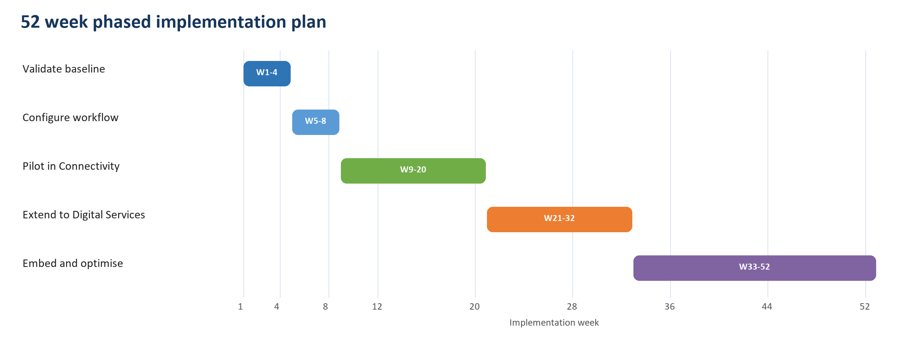
Table 5 Detailed work plan
Phase | Weeks | Key activities | Deliverables | Client owner / Student consultant
0 Validate | 1 to 4 | Retrieve records, screen criticality, establish VHCR, quantify rework and unplanned recovery | Baseline report, validated benefit case, confirmed scope | Client: Process Owner and Finance Partner  Consultant: Xuan Zeng
1 Configure | 5 to 8 | Configure fields and rules, create pack and competence protocol, design exception and reports | Configured workflow, control design, test scripts | Client: Process Owner, HRIS Analyst and Security Adviser  Consultant: Xuan Zeng
2 Pilot | 9 to 20 | Run Connectivity pilot, train users, review defects and exceptions weekly | Pilot report, revised process, go or no go decision | Client: Process Owner and Connectivity Change Lead  Consultant: Xuan Zeng
3 Extend | 21 to 32 | Roll out to Digital Services and in scope internal transfers | Division rollout, knowledge transfer and acceptance | Client: Divisional Leads and Process Owner  Consultant: Xuan Zeng
4 Embed | 33 to 52 | Monthly KPI review, quarterly assurance sample, handover to BAU | Operating dashboard, benefits register, closure report | Client: Executive Sponsor, Process Owner and Finance Partner  Consultant: Xuan Zeng

The main milestones are baseline approval at week 4, configuration sign-off at week 8, the pilot decision at week 20, acceptance of the second divisional rollout at week 32, and handover to normal operations at week 52.
The 52-week schedule translates the 12-month target from A1-D2 into a workable sequence. Four weeks are allowed for validation and four for configuration. Each divisional rollout then receives 12 weeks so that the team can observe real cases and correct problems before moving on. The final 20 weeks provide time for monthly KPI reviews and two quarterly assurance checks. These timings are assumptions. At the end of Phase 0, the steering committee should change the schedule if exit volumes, system lead times or staff availability do not support it.

7 Team and Capabilities
A small joint team is suitable because the proposal changes an existing workflow rather than introducing a new enterprise platform. Xuan Zeng would lead the analysis, reporting and process design. The Spark positions are shown as nomination profiles because no client appointments have been confirmed. Spark should name the people filling these roles before Phase 0 starts.
Table 6 Proposed implementation team
Role | Proposed member | Brief bio or required profile and project contribution
Project lead | Xuan Zeng | Xuan Zeng completed the A1-D1 diagnosis and A1-D2 analysis used in this proposal, including the BPMN models and cost estimates. For this project, Xuan would coordinate the work, present the findings and manage the phase gates.
Executive Sponsor | Spark executive nominee | A senior leader with authority across People, Finance, Security and both operating divisions. Connects the control to SPK 30, communicates its importance, resolves cross-divisional barriers and approves material scope, schedule and risk decisions.
Client Process Owner | People Services nominee | An operational owner experienced in employee lifecycle controls and cross-functional process management. Owns the end-to-end standard, KPI performance, exception decisions, documentation and continuous improvement after consultant exit.
Finance Benefits Lead | Finance business partner nominee | A finance professional able to distinguish planned backfill from unplanned capability-recovery cost. Validates the baseline, attribution rules, benefit forecast and quarterly value-realisation evidence.
HRIS and Workflow Analyst | Spark technology nominee | A practitioner familiar with Spark's HRIS, workflow configuration, reporting and access model. Configures fields, routing, dashboards and audit evidence while minimising customisation.
Security and Privacy Adviser | Spark risk nominee | A specialist familiar with access revocation, delegated access, retention and privacy obligations. Approves the data protocol and ensures the capability gate never delays security offboarding.
Divisional Change Leads | Connectivity and Digital Services nominees | Respected local leaders with access to managers and receiving owners. Translate the design into divisional practice, protect training time, collect feedback and confirm readiness before each rollout gate.

8 Change Management

8.1 Recommended change strategy
A phased implementation is recommended because the change affects managers, departing employees, receiving owners, People, IT access management and Finance. Mills (2025) explains that a big-bang approach can be quicker and cheaper because work is not repeated, but it places more scope and go-live risk into one event. Parallel delivery may also be fast, but its overlapping phases create the greatest dependency and workload burden for the client's staff. A phased approach reduces the amount of change at each go-live, suits limited client capacity and allows lessons from the first release to improve the next. That trade-off fits this proposal: Spark can test the control in Connectivity before extending it to Digital Services (INFOSYS 704, 2026).
Mills (2025) also identifies data, change management and training as common causes of implementation problems, and stresses that users must understand how their work and processes will change. The change plan therefore gives managers and receiving owners time for training and pilot work, uses weekly reviews to resolve practical issues, and checks adoption through completed competence tests and the 90-day reopen rate rather than attendance alone.

8.2 Change requirements and impacts
Table 7 Change impact assessment
Stakeholder | Change required | Likely concern | Adoption response
Line managers | Classify criticality and assign a receiving owner promptly | Additional work during high exit volume | Automate the initial screen; report overdue decisions; brief managers before pilot
Departing employees | Complete a standard pack and shadow selected tasks | Fairness, workload and privacy | Start early, define minimum evidence, exclude personal information and avoid credential capture
Receiving owners | Specify needs and perform competence checks | Time pressure and reluctance to reject | Protect time, make the role visible and allow two remediation cycles
People function | Manage a capability control as well as an administrative checklist | Perceived expansion of scope | Embed two mandatory fields and a clear escalation rule
Finance | Link recovery cost to exits | Attribution is imperfect | Use timing, role overlap and manager confirmation rather than ledger codes alone

8.3 Communication training and reinforcement
- Mobilisation briefing for the executive sponsor, process owner and divisional leads before week 1.
- Role based sessions for managers and receiving owners before the pilot, supported by worked examples and a one page decision guide.
- Weekly pilot office hours and exception review during weeks 9 to 20.
- A feedback review at T plus 45 days asking receiving owners what they had to rediscover, with findings used to improve the template and triage rules.
- Monthly publication of VHCR, CAC and HVLT together so that a high completion rate cannot conceal late or narrow classification.

9 Risk Management
The risk register follows Scott and Vessey's (2002) view that implementation risks interact across the business, organisation and information systems. It also reflects Mills's (2025) warning that uncontrolled scope can increase both cost and schedule. The RAG rating shows the remaining exposure after the proposed mitigation.
Table 8 Implementation risk register
ID and type | Risk description | Mitigation and owner | RAG and rationale
R1 Organisational | Receiving owners sign without testing competence | Require two or three real tasks; quarterly 10% assurance sample. Owner: Process Owner | Amber. Control reduces the risk, but workload pressure remains
R2 Organisational | The exception path becomes the default | Name every approver, block backfill approval, report overrides to the executive sponsor. Owner: Sponsor | Red. Cost pressure creates a strong incentive to bypass the gate
R3 Information systems | Critical roles are under classified | Use entitlements, system ownership and on call data; bias ambiguous cases upward. Owner: HRIS Analyst | Amber. Source data may be incomplete
R4 External business | The Digital Services review changes scope or ownership | Use a modular process and keep divisional accountability explicit. Owner: Sponsor | Amber. The event is likely, but the control can move with the organisation
R5 Project | Change fatigue lowers participation | Pilot in one division, keep phase one to two fields and one pack, schedule protected training. Owner: Change Lead | Amber. The change is small but occurs during restructuring
R6 Data and privacy | The pack contains credentials or personal information | Prohibit credential custody, apply retention rules, approve the template with Security and Privacy. Owner: Security Adviser | Green. Clear preventive controls are available
R7 Financial | Benefits are overstated because planned backfill is counted as leakage | Separate planned and unplanned spend using timing, scope overlap and manager evidence. Owner: Finance | Amber. Accounting codes alone will not resolve causality
R8 Project | Baseline records are unavailable | Test retrievability in week 1 and use ITSM consequence data if needed. Owner: Student Consultant | Amber. Missing records weaken precision but also evidence the control gap
R9 Project | Unapproved scope expands the workflow and delays phase gates | Record each change with its effort, fee, timeline and benefit impact; do not start it before steering approval. Owner: Sponsor | Amber. Clear control is available, but new requests are likely once users see the pilot

10 Expected Impact and Value Creation

10.1 Financial value
The A1-D2 sensitivity analysis estimated annual capability leakage of NZ$1.1 million to NZ$4.0 million, with a base case of NZ$2.4 million. This proposal uses a lower recovery target of NZ$1.4 million, or about 58% of that base case. If it is validated and achieved, the saving would improve EBITDAI by roughly the same amount because it is an operating cost reduction. No revenue growth is included.
Table 9 Three year cost benefit analysis in NZD
Item | Year 1 | Year 2 | Year 3 | Three year total
Recovered rework and unplanned contractor cost | $700,000 | $1,400,000 | $1,400,000 | $3,500,000
Implementation fee | $97,350 | $0 | $0 | $97,350
Ongoing assurance and reporting | $0 | $30,000 | $30,000 | $60,000
Net benefit | $602,650 | $1,370,000 | $1,370,000 | $3,342,650

Using these assumptions, the nominal benefit-cost ratio is 22.2 and the three-year ROI is about 2,124%. Year one includes only half of the annual benefit because the process is introduced in stages. These are indicative figures, not a commitment. Phase 0 must replace the assumptions with Spark data before the business case is approved.

10.2 Strategic operational and organisational value
- The strategic value is better protection for the network reliability and customer experience capabilities required by SPK 30.
- Operationally, the proposal should reduce rework, escalation and the time a receiving team needs before it can work independently.
- For the organisation, it gives someone clear responsibility for retaining capability and shows where deputy coverage is still weak.
- For governance, it links labour savings to recovery costs that might otherwise be hidden in project and contractor budgets.
Figure 4 Impact value matrix
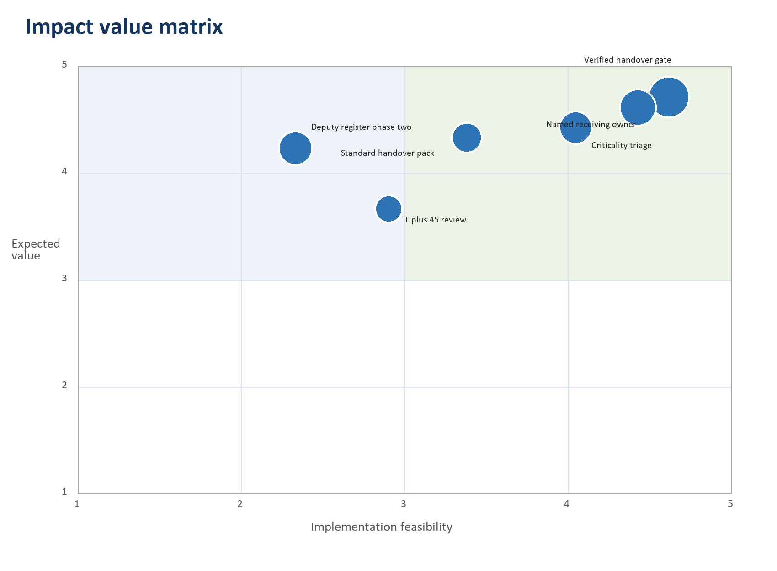
Bubble size shows the estimated share of the NZ$1.4 million annual recovery target. The scores are proposal judgements and should be checked with Spark stakeholders during Phase 0.

11 Client Responsibilities and Collaboration Model
Spark will need to provide decision authority, access to the required data and staff who can own the process after the project. Mills (2025) argues that client and consultant responsibilities should be agreed at a detailed level and then mapped into the delivery plan. Tables 10 and 11 apply that principle through named commitments, joint forums and clear operating ownership. The consultant will not retain identifiable employee data; Spark will create the pseudonymised keys used to link the datasets.
Table 10 Client responsibilities
Client commitment | Required timing | Why it is needed
Nominate executive sponsor and process owner | Before kick off | Provides authority and a durable owner
Provide controlled access to HRIS, entitlement, ITSM and finance records | Week 1 | Establishes the baseline and tests the value case
Provide SMEs from People, Finance, Security, IT and both divisions | Weeks 1 to 8 | Validates controls, data and operating feasibility
Release pilot participants for training and competence checks | Weeks 8 to 20 | Prevents adoption from being displaced by normal workload
Attend decision forums and resolve escalations | Weekly pilot and monthly steering | Keeps issues within the agreed timebox

11.1 Governance and meeting cadence
Table 11 Proposed collaboration forums
Forum | Participants | Timing | Agenda
Steering committee | Sponsor, Student Consultant, Process Owner, Finance, Divisional Leads | Monthly, 60 minutes | Scope, milestones, value, red risks and decisions
Delivery stand up | Core project team | Weekly, 30 minutes | Completed work, next work, blockers and dependencies
Pilot exception review | Process Owner, Change Lead, managers, Security as needed | Weekly in pilot, 45 minutes | Failed checks, overrides, root causes and corrective actions
Benefits review | Finance, Process Owner, Student Consultant | Quarterly, 60 minutes | VHCR, ITSM outcomes, attributable cost and benefit forecast

11.2 Knowledge transfer
Knowledge transfer will take place throughout the project. Spark staff will help design the configuration and test cases, own the process documents, receive administrator guidance before the pilot and lead the week 52 handover. The final acceptance test is practical: the process owner must be able to run the monthly dashboard, manage an exception and update the handover standard without consultant support.

12 Commercials
The fee is fixed by phase and assumes remote delivery, Spark's existing workflow environment, and timely access to staff and data. Consistent with Mills's (2025) advice on fixed-price risk, the assumptions are stated and a 10% contingency requires steering committee approval. New software licences, travel and major integration work are excluded.
Table 12 Fee and phase distribution
Phase | Consulting effort | Fee NZD | Payment milestone
0 Validate | 15 days | $22,500 | On acceptance of baseline and validated value case
Mobilise | 9 days | $13,500 | On confirmation of governance and data access
1 Configure | 12 days | $18,000 | On configuration and design sign off
2 Pilot | 10 days | $15,000 | On pilot gate decision
3 Extend | 7 days | $10,500 | On divisional rollout acceptance
4 Embed | 6 days | $9,000 | On operational handover
Contingency | 10% of professional fees | $8,850 | Used only with steering committee approval
Total | 59 days plus contingency | $97,350 | Excluding GST

12.1 Capex and Opex treatment
No new platform purchase is included, so the current estimate has no capital expenditure. Professional services, configuration, training and assurance are treated as operating expenditure. Spark staff time is an opportunity cost and is not included in the fee. Spark's accounting policy will determine the final classification.

12.2 Commercial terms
- Invoices are issued at the stated phase acceptance points and payable within 20 business days.
- Scope changes require written agreement on the effect on fee, schedule and deliverables. No work on the additional scope will begin until the steering committee has approved the change, consistent with Mills's (2025) advice on preventing cost and schedule overruns.
- Spark owns the configured workflow, templates, test cases and reports produced for the engagement.
- Either party may terminate for material breach after ten business days to remedy. Spark pays for accepted work completed to the termination date.

13 Next Steps
Spark is asked to approve Phase 0 and the delivery model by 23 September 2026. If the required people and data are available, the proposed kick-off date is 28 September 2026.
- Confirm the executive sponsor, client process owner, Finance lead and divisional representatives.
- Approve the Phase 0 data access protocol and pseudonymisation method.
- Schedule the 90 minute kick off workshop and the four week baseline review.
- Release the required HRIS, entitlement, ITSM and finance extracts to the approved analysis environment.
- At the week 4 gate, confirm the benefit baseline, pilot scope and authority to configure the workflow.
The immediate decision is to approve the NZ$22,500 validation phase. This allows Spark to test the evidence and value case before committing to configuration or wider rollout.

14 Learning Journeys
The five Learning Journeys offer practical ways to test and strengthen the proposal; they do not mean that Spark should buy all five SAP products. Following the course clarification, Table 13 separates each high-level proposal improvement from the specific SAP functionality and then traces that functionality to its Learning Journey, Course, Unit and Lesson. Every functionality listed below is covered in the supplied Learning Journey material, so no entry needs to be marked 'Not Covered in the LJs.'
Figure 5 Potential improvements to the A2 D1 proposal using the five SAP Learning Journeys
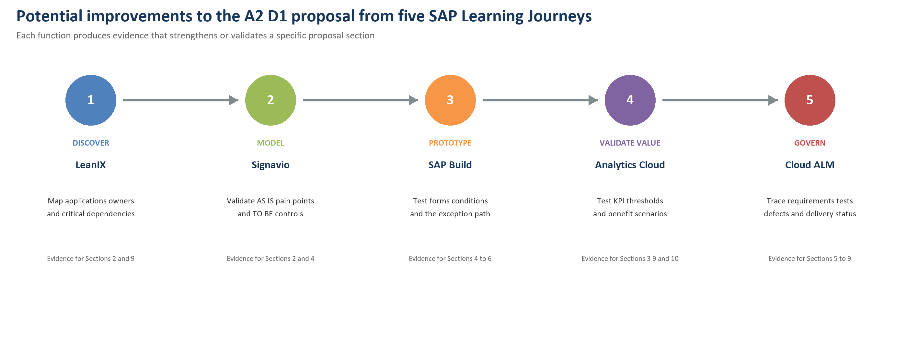
Table 13 Learning Journey functionality and exact traceability
High-level proposal improvement | Specific SAP functionality | Evidence and A2-D1 section | Exact LJ, Course, Unit and Lesson
Make the problem diagnosis and business impact easier to trace | SAP Signavio process variation, inefficiency and business-impact analysis | Annotated AS-IS model and pain-point register; Sections 2 and 10 | LJ: Managing Business Processes with SAP Signavio Solutions. Course: Managing Business Processes with SAP Signavio Solutions. Unit: Exploring the Foundations of Business Processes. Lessons: Analyzing Process Variation and Inefficiency; Relating Process Problems to Business Impact.
Check that the proposed controls are represented correctly in BPMN | SAP Signavio BPMN 2.0 task ownership, lanes, gateways and sequence-flow conditions | Syntax-checked AS-IS and TO-BE models; Sections 2 and 4 | LJ: Managing Business Processes with SAP Signavio Solutions. Course: Managing Business Processes with SAP Signavio Solutions. Unit: Process Modeling and Design. Lessons: Responsibilities for Task Assignment; Gateways - Control the Process Flow; Introduction to Business Process Modeling in Practice (BPMN 2.0).
Make criticality rules reflect the systems and capabilities that depend on a role | SAP LeanIX fact sheets and dependency relations | Capability, application, owner and dependency map; Sections 2, 4 and 9 | LJ: Learning to Use LeanIX for Successful Enterprise Architecture. Course: Learning to Use SAP LeanIX for Successful Enterprise Architecture. Unit: Modeling Fact Sheets in SAP LeanIX. Lesson: Defining SAP LeanIX Fact Sheets and Modeling Relations and Dependencies.
Prioritise the applications and capabilities with the greatest service exposure | SAP LeanIX reports and Application Portfolio Assessment | Ranked application portfolio and critical-exit scope; Sections 4 and 9 | LJ: Learning to Use LeanIX for Successful Enterprise Architecture. Course: Learning to Use SAP LeanIX for Successful Enterprise Architecture. Units: Analyzing and Communicating Data with SAP LeanIX Reports; Application Portfolio Assessment with SAP LeanIX. Lessons: Understanding Key SAP LeanIX Reports; Engaging in Step-by-Step Application Portfolio Assessment.
Make the handover KPIs easier for managers to interpret and act on | SAP Analytics Cloud story charts and conditional formatting | Dashboard showing VHCR, CAC, HVLT, recovery cost, target, actual and RAG status; Sections 3, 9 and 10 | LJ: Becoming a Certified Data Analyst in SAP Analytics Cloud. Course: Designing Stories in SAP Analytics Cloud. Unit: Configuring Story Elements. Lessons: Configuring Charts; Applying Conditional Formatting.
Test whether the financial case remains credible when assumptions change | SAP Analytics Cloud calculations and value-driver simulation | Scenarios for completion rate, recoverable cost and benefit ramp; Sections 10 and 12 | LJ: Becoming a Certified Data Analyst in SAP Analytics Cloud. Courses: Designing Stories in SAP Analytics Cloud; Leveraging Advanced Features in SAP Analytics Cloud for Planning. Units: Manipulating Data in Stories; Forecasting and Simulating Planning Data. Lessons: Calculating Data in Stories; Simulating Data with Value Driver Trees.
Test the proposed workflow before changing Spark's production environment | SAP Build digital forms and process conditions | Executable criticality screen, handover pack and Yes/No routing prototype; Sections 4, 5 and 8 | LJ: Developing with SAP Build - From Apps to Automation. Course: Developing with SAP Build Process Automation. Unit: Performing Basic Process Building in SAP Build Process Automation. Lessons: Digitalizing User Interactions with Forms; Using Conditions to Control the Process Flow.
Check that remediation and exception routing work under realistic cases | SAP Build decision logic, deployment and process monitoring | Monitored verification, remediation and named-exception test cases; Sections 4, 6 and 9 | LJ: Developing with SAP Build - From Apps to Automation. Course: Developing with SAP Build Process Automation. Units: Performing Basic Process Building in SAP Build Process Automation; Using Features of Advanced Process Building in SAP Build Process Automation. Lessons: Releasing, Deploying, Running, and Monitoring the Process; Improving the Sales Order Management Process with Decision Logic.
Strengthen requirement ownership and control changes to the agreed scope | SAP Cloud ALM project teams and requirements management | Role-assigned backlog and trace from requirement to business reason; Sections 5, 6, 7 and 11 | LJ: Transforming for Success with SAP Cloud ALM. Course: Implementing with SAP Cloud ALM. Units and lessons: Setting-Up the Project and Teams; Managing Requirements.
Make phase-gate decisions depend on visible test and rollout evidence | SAP Cloud ALM testing, analytics and implementation reporting | Test plan, defect history and implementation status report; Sections 6, 8 and 9 | LJ: Transforming for Success with SAP Cloud ALM. Course: Implementing with SAP Cloud ALM. Units and lessons: Planning and Executing Testing; Using Analytics and Reporting.

Figure 5 shows the connection across the five journeys: discover dependencies, model the process, prototype the workflow, validate the value case and govern implementation. Table 13 provides the detail required by the course clarification, including the evidence each function would produce and the proposal section it would strengthen.

15 References and Academic Integrity
Bennett, B. (2026, July 31). Spark restructure separates digital services from connectivity. Scoop. https://www.scoop.co.nz/stories/SC2607/S00045/spark-restructure-separates-digital-services-from-connectivity.htm
Commerce Commission. (2025). 2024 telecommunications monitoring report. https://www.comcom.govt.nz/assets/pdf_file/0025/367054/2024-Telecommunications-Monitoring-Report-30-June-2025.pdf
Harvey, K. (2025, October 30). Best and worst mobile providers. Consumer NZ. https://www.consumer.org.nz/tech/internet-and-mobile/best-and-worst-mobile-providers
INFOSYS 704. (2026). Week 5 Lecture 7: Implementation scenarios and strategies [PowerPoint slides]. University of Auckland.
Markus, M. L., & Tanis, C. (2000). The enterprise systems experience: From adoption to success. In R. W. Zmud (Ed.), Framing the domains of IT management: Projecting the future through the past (pp. 173-207). Pinnaflex Educational Resources.
Mills, A. (2025, August 26). Guest lecture on ERP implementation [Video]. INFOSYS 704, University of Auckland. Panopto. https://auckland.au.panopto.com/Panopto/Pages/Viewer.aspx?id=745dbda2-e7d0-4a34-971a-b33d00f7aed1
Pelletier, N. (2024, September 17). Spark plans to cut $50m from labour costs. RNZ. https://www.rnz.co.nz/news/business/528207/spark-plans-to-cut-50m-from-labour-costs
Rosemann, M. (2006). Potential pitfalls of process modeling: Part A. Business Process Management Journal, 12(2), 249-254. https://doi.org/10.1108/14637150610657567
SAP. (n.d.-a). Becoming a Certified Data Analyst in SAP Analytics Cloud [Learning journey]. https://learning.sap.com/learning-journeys/becoming-a-certified-data-analyst-in-sap-analytics-cloud
SAP. (n.d.-b). Designing stories in SAP Analytics Cloud [Course]. https://learning.sap.com/courses/designing-stories-in-sap-analytics-cloud
SAP. (n.d.-c). Developing with SAP Build: From apps to automation [Learning journey]. https://learning.sap.com/learning-journeys/developing-with-sap-build-from-apps-to-automation
SAP. (n.d.-d). Developing with SAP Build Process Automation [Course]. https://learning.sap.com/courses/developing-with-sap-build-process-automation
SAP. (n.d.-e). Implementing with SAP Cloud ALM [Course]. https://learning.sap.com/courses/implementing-with-sap-cloud-alm
SAP. (n.d.-f). Learning to use LeanIX for successful enterprise architecture [Learning journey]. https://learning.sap.com/learning-journeys/learning-to-use-the-leanix-tool-for-successful-enterprise-architecture
SAP. (n.d.-g). Learning to use SAP LeanIX for successful enterprise architecture [Course]. https://learning.sap.com/courses/learning-to-use-sap-leanix-for-successful-enterprise-architecture
SAP. (n.d.-h). Leveraging advanced features in SAP Analytics Cloud for planning [Course]. https://learning.sap.com/courses/leveraging-advanced-features-in-sap-analytics-cloud-for-planning
SAP. (n.d.-i). Managing business processes with SAP Signavio solutions [Course]. https://learning.sap.com/courses/managing-business-processes-with-sap-signavio-solutions
SAP. (n.d.-j). Managing business processes with SAP Signavio solutions [Learning journey]. https://learning.sap.com/learning-journeys/managing-business-processes-with-sap-signavio-solutions
SAP. (n.d.-k). Transforming for success with SAP Cloud ALM [Learning journey]. https://learning.sap.com/learning-journeys/transforming-for-success-with-sap-cloud-alm
Scott, J. E., & Vessey, I. (2002). Managing risks in enterprise systems implementations. Communications of the ACM, 45(4), 74-81. https://doi.org/10.1145/505248.505249
Spark New Zealand. (2025a). Annual report FY25. https://www.spark.co.nz/content/dam/spark/documents/pdfs/governance/FY25_Annual_Report.pdf
Spark New Zealand. (2025b). Spark releases FY30 strategy and update on Chair succession. https://www.spark.co.nz/online/about/our-company/news/Spark-releases-FY30-strategy-and-update-on-Chair-succession
Spark New Zealand. (2026, February 18). Mobile momentum and cost out return Spark to profit growth in H1 FY26. https://www.spark.co.nz/online/about/our-company/news/Mobile-momentum-and-cost-out-return-Spark-to-profit-growth-in-H1-FY26

15.1 Statement on the use of generative AI
I used generative AI to help me understand the assignment requirements, identify the information needed for each section, support targeted information searches, and refine the document's formatting and page layout. I reviewed the sources and checked the analysis, calculations, diagrams, Learning Journey mapping and references against the original materials. The final selection of evidence, interpretation and recommendations is my own responsibility.

Appendix A Key Assumptions
Table A1 Assumptions requiring client validation
Assumption | Working value | Validation in Phase 0
Exits from knowledge critical roles | 25% of exits | Apply documented rules to the FY24 to FY26 population
Unverified handover rate | Above 50% | Review artefacts and receiver acceptance for a statistically useful sample
Receiving team rework | 30 days at NZ$550 per day | Use ITSM, time records and manager sampling
Contractor recovery | 15% of unverified critical exits | Link timing, role overlap and engagement purpose
Annual recoverable value | NZ$1.4 million | Recalculate after baseline and remove planned backfill
Technology scope | Existing workflow environment can support two fields, routing and reports | Confirm with HRIS and workflow owners in week 1

